**DRUG TRACEABILITY**

## **A PROJECT REPORT**

***Submitted by***

|  |  |
| --- | --- |
| **NARESH K** | **622620104016** |
| **MANIGANDAN K** | **622620104012** |
| **SATHEESH KUMAR G** | **622620104023** |
| **ABITHA S** | **622620104301** |
|  |  |

# TEAM ID: NM2023TMID11490

In partial fulfillment for the award of the degree

***Of***

# BACHELOR OF ENGINEERING

## **IN**



**COMPUTER SCIENCE AND ENGINEERING**

**SHREENIVASA COLLEGE OF ENGINEERING**

## **BOMMIDI,DHARMAPURI-636807**

# TABLE OF CONTENT

# INTRODUCTION

* 1. Project Overview
  2. Purpose

# LITERATURE SURVEY

* 1. Existing problem
  2. References
  3. Problem Statement Definition

# IDEATION & PROPOSED SOLUTION

* 1. Empathy Map Canvas
  2. Ideation & Brainstorming

# REQUIREMENT ANALYSIS

* 1. Functional requirement
  2. Non-Functional requirements

# PROJECT DESIGN

* 1. Data Flow Diagrams & User Stories
  2. Solution Architecture

# PROJECT PLANNING

* 1. Technical Architecture

# CODING & SOLUTIONING

* 1. Feature

# PERFORMANCE TESTING

# RESULTS

* 1. Output Screenshots

# ADVANTAGES & DISADVANTAGES

# 10.1Advantages

# 10.2 Disadvantages

1. **CONCLUSION**

# FUTURE SCOPE

1. **APPENDIX**

13.1 Source Code

13.2 GitHub & Project Demo Link

**1. INTRODUCTION**

**1.1 PROJECT OVERVIEW:**

**Healthcare supply chains are complex structures spanning across multiple organizational and geographical boundaries, providing critical backbone to services vital for everyday life. The inherent complexity of such systems can introduce impurities including inaccurate information, lack of transparency and limited data provenance.**

**Counterfeit drugs is one consequence of such limitations within existing supply chains which not only has serious adverse impact on human health but also causes severe economic loss to the healthcare industry.**

**1.2 PURPOSE:**

**The existing studies have emphasized the need for a robust, end-to-end track and trace system for pharmaceutical supply chains. Therein, an end-to-end product tracking system across the pharmaceutical supply chain is paramount to ensuring product safety and eliminating counterfeits.**

**Most existing track and trace systems are centralized leading to data privacy, transparency and authenticity issues in healthcare supply chains. In this article, we present an Ethereum blockchain-based approach leveraging smart contracts and decentralized off-chain storage for efficient product traceability in the healthcare supply chain.**

**2. LITERATURE SURVEY**

**2.1 Existing problem:**

**Traceability is defined as the ability to access any or all information relating to the object under consideration, throughout its life cycle, by means of recorded identifications. The object under consideration is referred to as Traceable Resource Unit (TRU) which is any traceable object within the supply chain.**

Traceability objectives are twofold; to track the history of transactions, and to track the real-time position of the TRU. In this context, a traceability system requires access to information related to the drug which is the TRU in the supply chain by using different identification techniques to record its identity and distinguish it from other TRUs. The components of a traceability system can be broadly identified by a mechanism for identifying TRUs, a mechanism for documenting the connections between TRUs, and a mechanism for recording the attributes of the TRUs.

**2.2 References**

**Therein, an end-to-end product tracking system across the pharmaceutical supply chain is paramount to ensuring product safety and eliminating counterfeits. Most existing track and trace systems are centralized leading to data privacy, transparency and authenticity issues in healthcare supply chains.**

*Shortage of Personal Protective Equipment Endangering Health Workers Worldwide*, Jun. 2020

W. G. Chambliss, W. A. Carroll, D. Kennedy, D. Levine, M. A. Moné, L. D. Ried, et al., "Role of the pharmacist in preventing distribution of counterfeit medications", *J. Amer. Pharmacists Assoc.*, vol. 52, no. 2, pp. 195-199

Z. RJ, "Roles for pharmacy in combating counterfeit drugs", J. Amer. Pharmacists Assoc., vol. 48, pp. e71-e88

**2.3 Problem Statement Definition:**

It presents a high-level architecture for the proposed drug traceability system together with the stakeholder and their interactions with the smart contract. The stakeholders are envisioned to access the smart contract, decentralized storage system and on-chain resources through software devices that have front-end layer denoted by a DApp (Decentralized Application) which is connected to the smart contract, on-chain resources, and decentralized storage system by an application program interface (API) such as Infura, Web3, and JSON RPC. The stakeholders will interact with the smart contract to initiate pre-authorized function calls and with the decentralized storage systems to access data files. Finally, their interaction with the on-chain resources will be for obtaining information such as logs, IPFS hashes, and transactions. More details on the system components are presented below.

**Stakeholders** include regulatory agencies such as FDA, manufacturers, distributors, pharmacies, and patients. These stakeholders act as participants in the smart contract and are assigned specific functions based on their role in the supply chain. They are also given access to the on-chain resources such as history and log information to track transactions in supply chain

**Ethereum Smart Contract** is used to handle the deployment of the supply chain. The smart contract is central and essential for tracking the history of transactions and manages the hashes from the decentralized storage server which allows the participants to access the supply chain information.

**3. IDEATION & PROPOSED SOLUTION:**

**3.1 Empathy Map Canvas:**

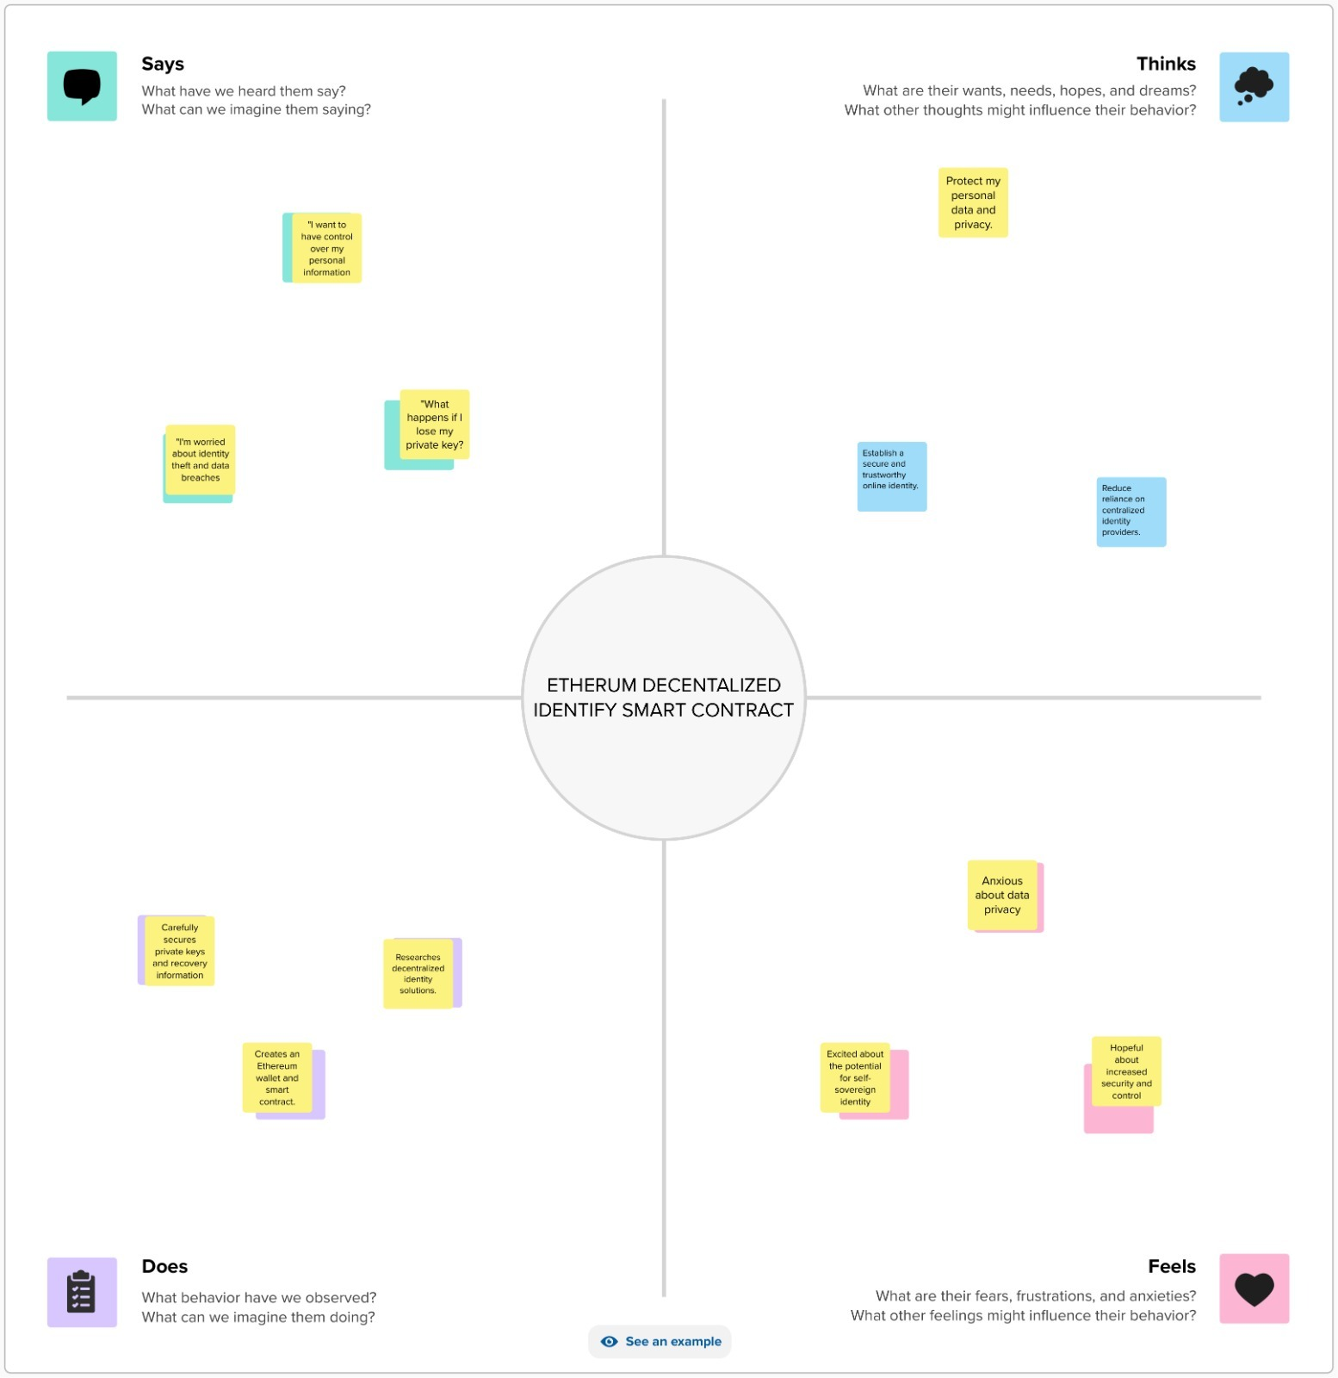

**3.2 Ideation & Brainstorming**

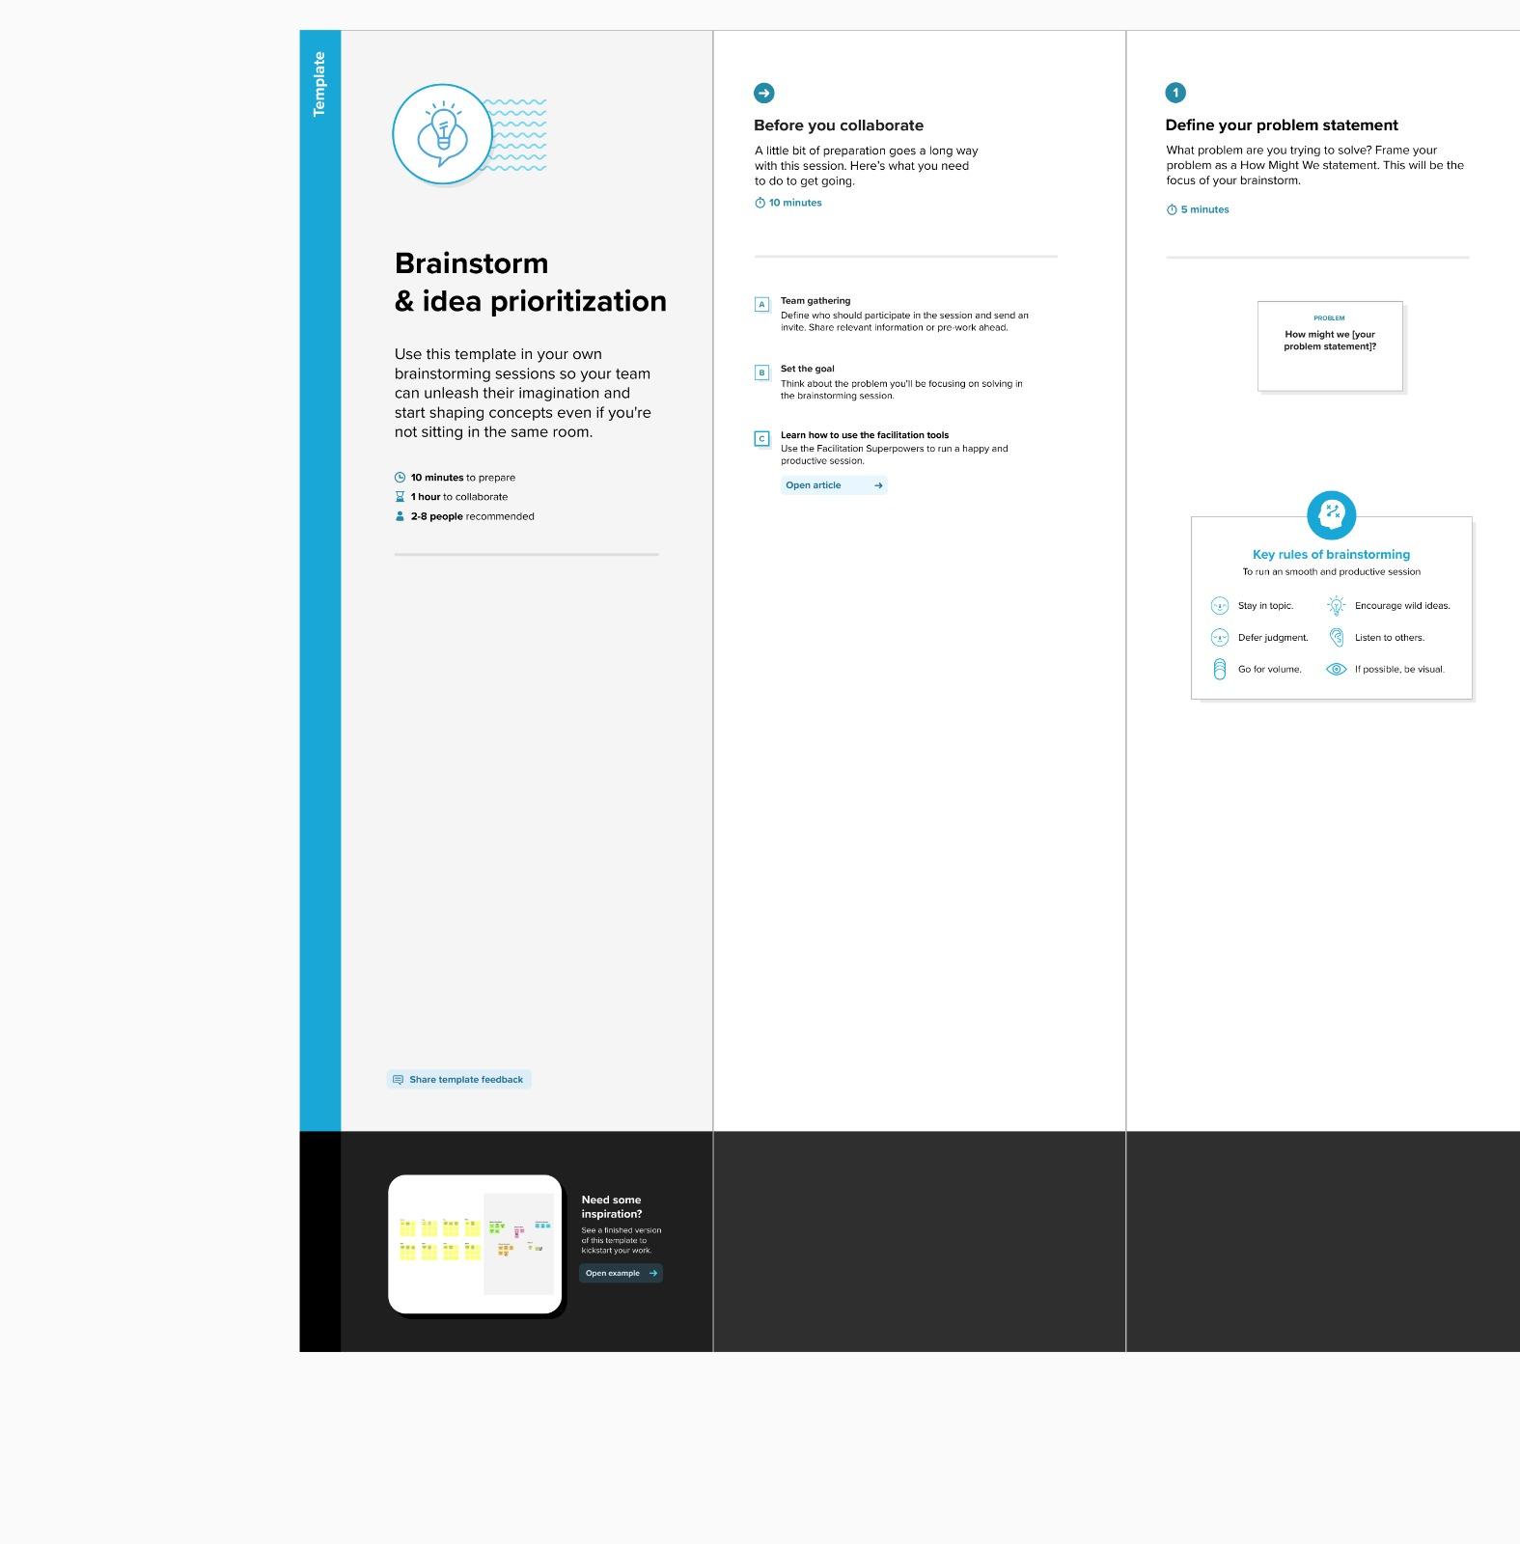

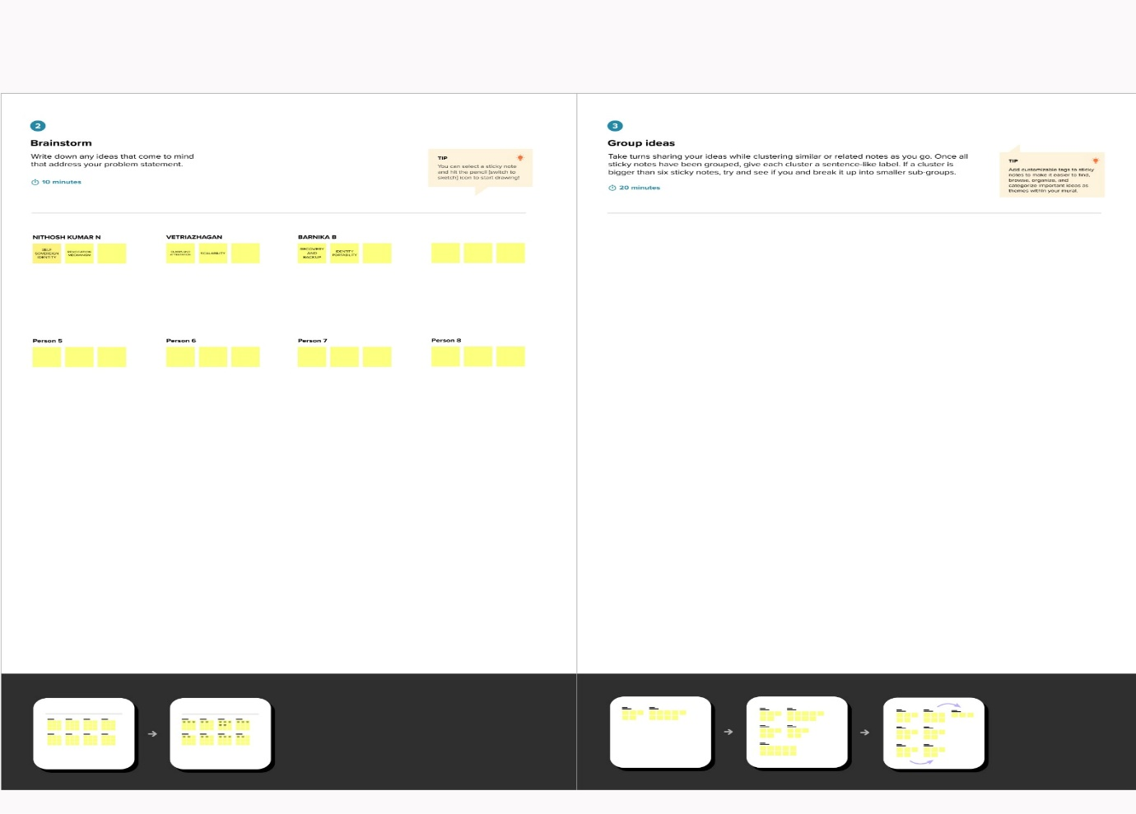

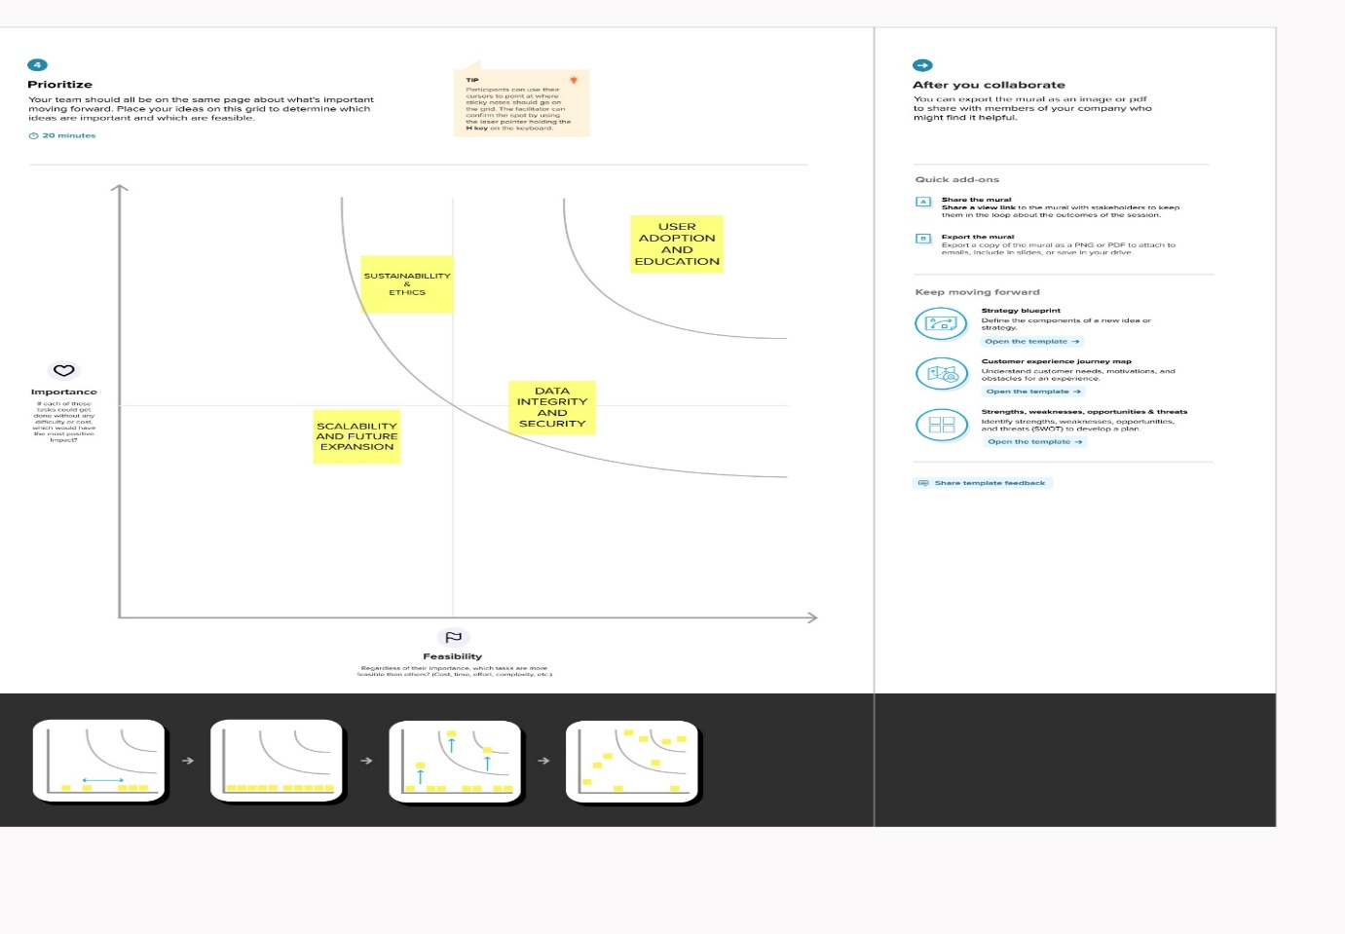

**4. REQUIREMENT ANALYSIS:**

**4.1 Functional requirement:**

1) The Inventory Module (IM) is a complete list of the medical equipment data, such as name, brand, model and functional status. Only the nurse assigned to a specific clinical area can access to the medical equipment information of that area.

2) The Tracking Work Order Module (TWOM), nurses can monitor the functional status of the device and send a report and service request to DBE.

3) The Maintenance Logbook Module (MLM) is composed of fields data about the service history of the medical equipment.

4) The Quick Reference Module (QRM) allows access to manuals and user guides of medical equipment assigned to a specific medical area.

5) Technovigilance Module (TM) is implemented to assist nursing activities identifying potential risks, take effective measures to protect the health of patients and user, send notifications, perform registration and systematic evaluation of adverse events to determine their frequency, severity and impact as well as to prevent its occurrence and minimize its risks.

**4.2. Non-Functional Requirements:**

1. **Security:** The system must be secure from unauthorized access.
2. **Performance:** The system must be able to handle the required number of users without any degradation in performance.
3. **Scalability:** The system must be able to scale up or down as needed.
4. **Availability:** The system must be available when needed.
5. **Maintenance:** The system must be easy to maintain and update.
6. **Portability:** The system must be able to run on different platforms with minimal changes.
7. **Reliability:** The system must be reliable and meet the requirements of the user.
8. **Usability:**The system must be easy to use and understand.
9. **Compatibility:** The system must be compatible with other systems.
10. **Compliance:** The system must comply with all applicable laws and regulations.

**5. PROJECT DESIGN:**

**5.1 Data Flow Diagrams & User Stories:**

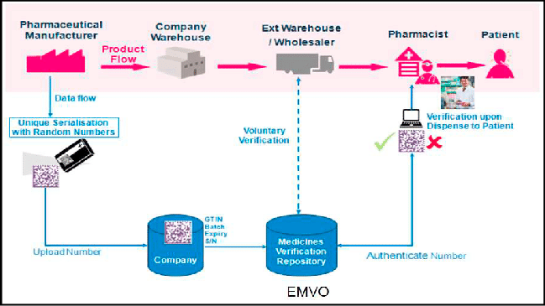

**5.2 Solution Architecture:**

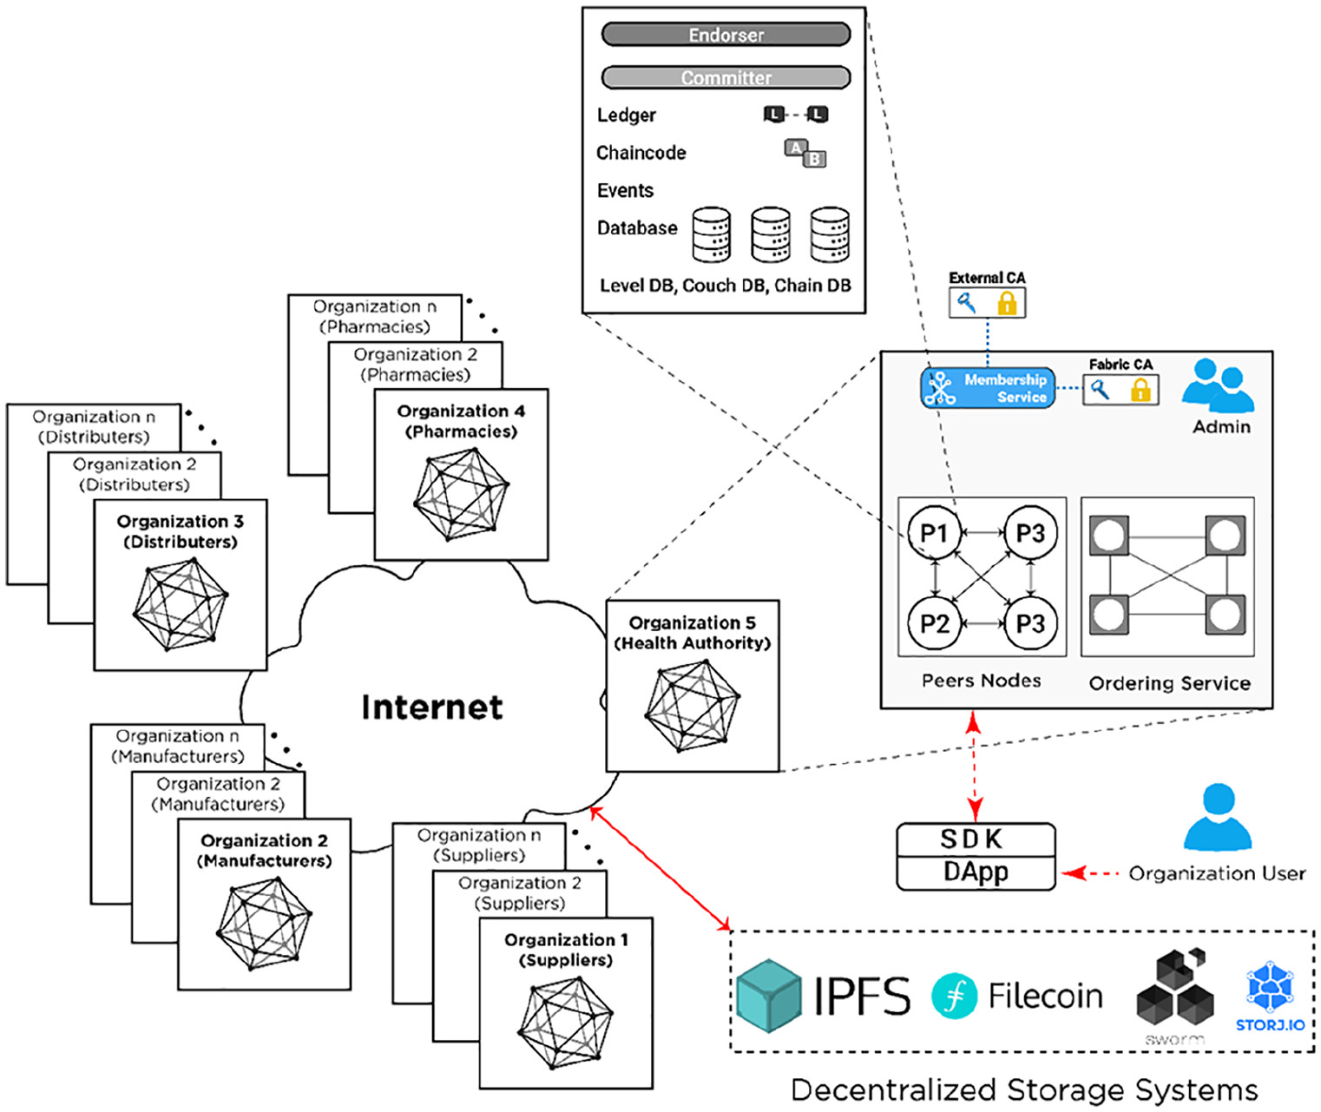

**6. PROJECT PLANNING:**

**6.1 Technical Architecture:**

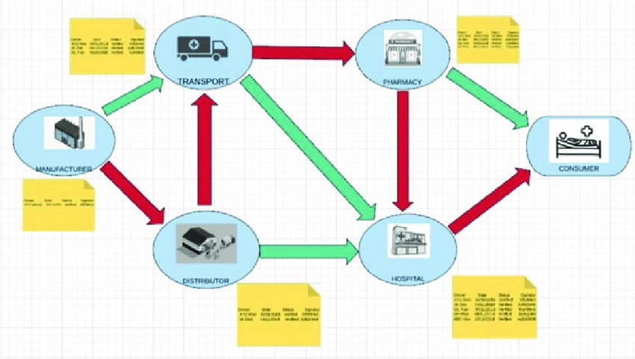

**7. CODING & SOLUTIONING:**

The proposed Hyperledger Besu drug traceability architecture provides a fully compatible open-source distributed ledger solution for enterprises looking for Ethereum-compatible blockchain architectures.

Hyperledger Besu is gaining popularity among enterprises as it supports building networks supporting both private transaction processing and integration with public blockchains (Ethereum), while maintaining architectural flexibility and high transaction throughput.

The proposed Hyperledger Besu architecture bridges the gap between private and public blockchains and helps pharmaceutical supply chain organizations to build scalable, high-performance applications on peer-to-peer private networks that fully support data privacy and complex permissioning management.

Hyperledger Besu supports business logic through Solidity smart contracts, and can take advantage of using ERC20 tokens and Ether cryptocurrency.

Hyperledger Besu is an open-source Ethereum client. It provides a simple JSON-RPC API for running and managing Hyperledger Besu nodes and executing transactions.

The proposed Hyperledger Besu architecture supports storing both private and public drug transaction execution information, which is required to implement an efficient drug traceability across the pharmaceutical supply chain between different stakeholders

8. PERFORMANCE TESTING:

**8.1 Performace Metrics:**

|  |  |  |  |
| --- | --- | --- | --- |
| **S.No.** | **Parameter** | **Values** | **Screenshot** |
| 1. | Information gathering | Setup all the Prerequisite: |  |
| 2. | Extract the zip files | Open to google chrome |  |

|  |  |  |  |
| --- | --- | --- | --- |
| 3. | Remix Ide platform explorting | Deploy the smart contract code  Deploy and run the transaction. By selecting the environment - inject the MetaMask. |  |
| 4 | Open file explorer | Open the extracted file and click on the folder. |  |
|  |  |  |  |

**9. RESULTS:**

**9.1 OUTPUT SCREENSHOTS:**

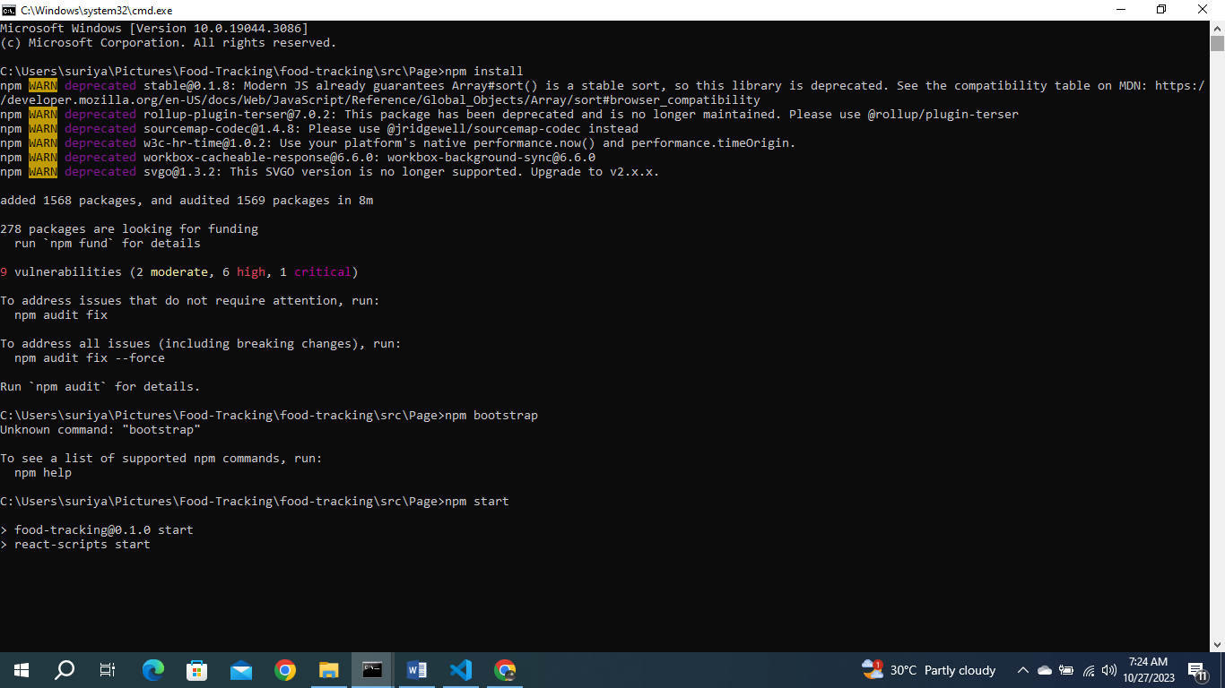

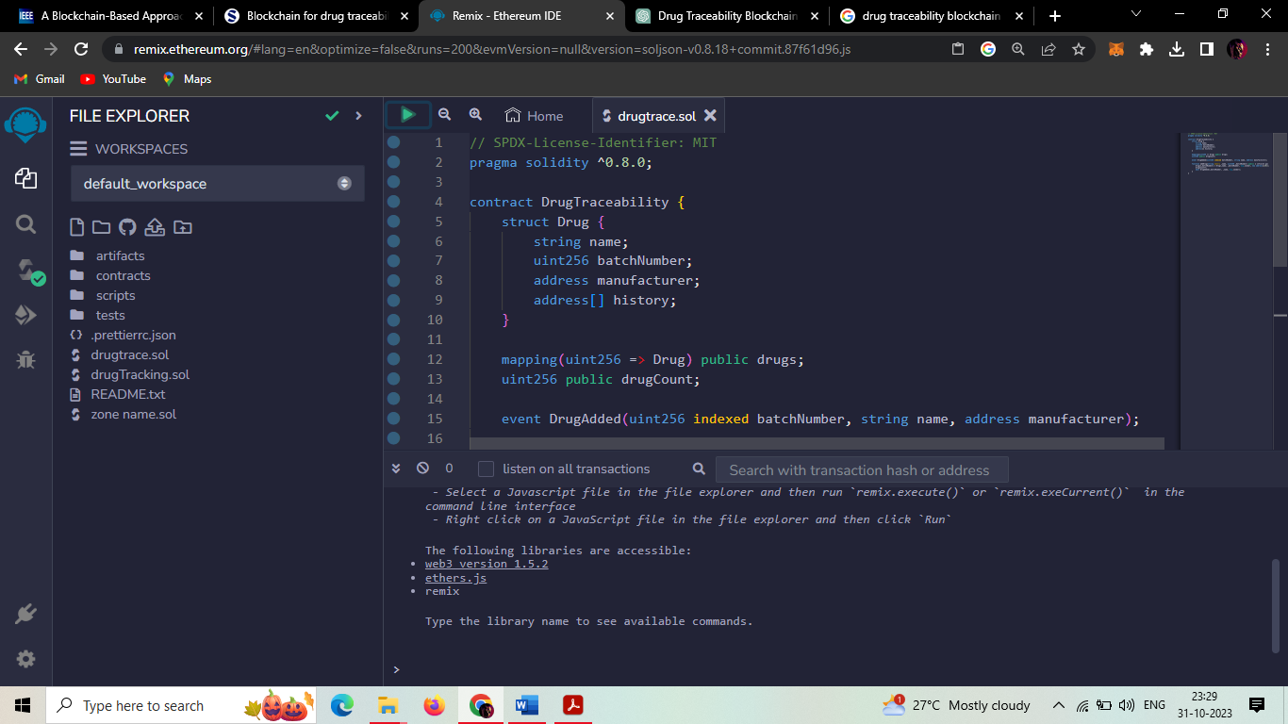

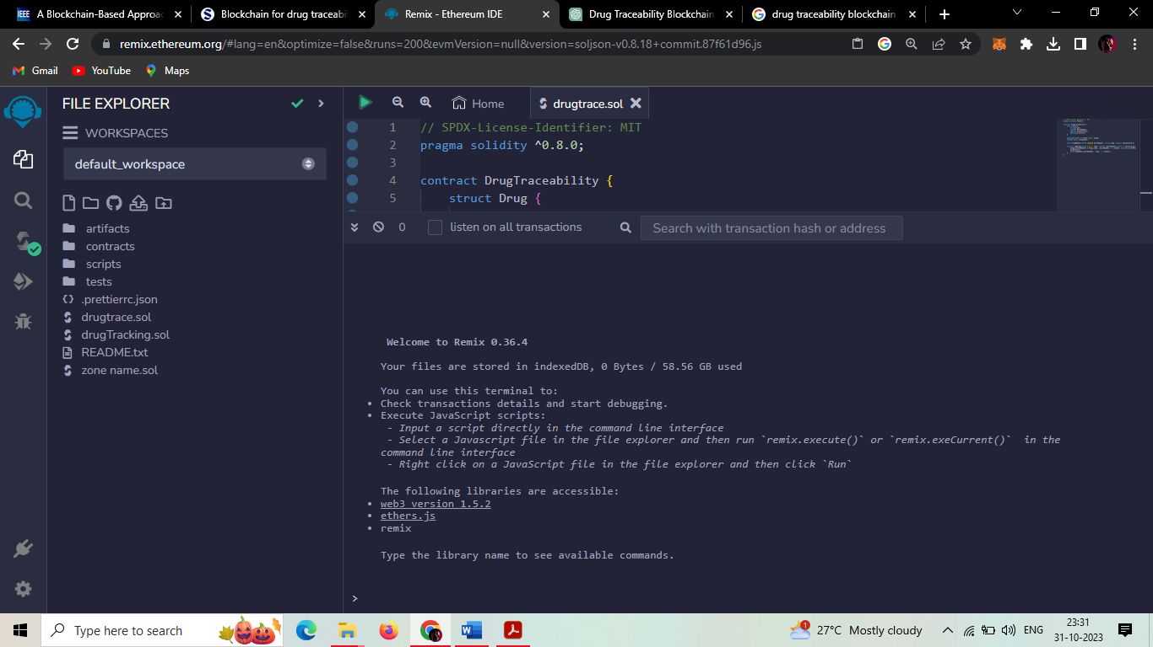

**10. ADVANTAGE & DISADVANTAGE:**

**10.1 ADVANTAGE:**

**Integrity**: The primary objective of the proposed blockchain solution is to keep track of all the transactions that occur within the healthcare supply chain ensuring traceability of the history of the Lots, ownership transfers and their corresponding boxes. This is ensured in the proposed solution because all events and logs are stored in the immutable blockchain ledger.

**Accountability**: As demonstrated in section V, each execution of a function has the Ethereum address of the caller stored on the blockchain which means tracing the function caller is always possible. Therefore, all the participants are accountable for their actions. In the healthcare supply chain, the manufacturer will be accountable for any drug Lot he produces using the lotDetails function

**Authorization**: The critical functions in the smart contract can only be executed by authorised participants by using the modifier. This ensures protection against unprivileged access and prevention of any unwanted entities from using the implemented functions.

**Availability**: Blockchains are decentralized and distributed by nature. Therefore, once the smart contract is deployed on the blockchain,  all logs and transactions are accessible to all participants. Contrary to centralized approaches, the transaction data is stored at all participating nodes therefore loss of a node does not result in the loss of transaction data

**Non-Repudiation**: As transactions are cryptographically signed by the private key of their initiators, cryptographic properties of PKI guarantee that private keys cannot be deduced from public keys. Therefore, a transaction signed by a specific private key can be attributed to the owner of the key.

**MITM Attacks**: Every transaction in the blockchain needs to be signed by its initiator’s private key, and therefore if an intruder tries to modify any of the original data and information in the blockchain it will not be confirmed unless it gets signed by the initiator’s private key. Therefore, MITM attacks are not possible in the blockchain environment.

**10.2 DISADVANTAGE:**

Cost of Implementation and Maintenance:

Building and maintaining a blockchain-based system can be expensive, particularly in terms of development, infrastructure, and ongoing maintenance. This cost may be a significant barrier for smaller producers or businesses with limited resources.

Scalability Challenges:

Depending on the scale of your project and the number of transactions involved, you may encounter scalability issues with the Ethereum blockchain. High transaction volumes could lead to slower processing times and increased gas fees.

Integration Complexity:

Integrating the blockchain system with existing systems, databases, and software used in the food supply chain may be complex and require significant customization. This could lead to disruptions in existing operations.

Privacy Concerns:

Blockchain technology provides transparency, it also means that sensitive information may be visible to all participants in the network. Ensuring privacy for certain types of data (e.g., proprietary recipes or trade secrets) may be challenging.

**11. CONCLUSION:**

**In this paper, we discuss how blockchain technology can be leveraged for drug traceability application in the pharmaceutical supply chain. We proposed two blockchain architectures based on Hyperledger Fabric and Hyperledger Besu. Such architectures provide a shared, trusted, permissioned and decentralized platform for storage and communications among different pharmaceutical supply chain stakeholders, and in a manner that can fulfill key requirements and features that include security, privacy, accessibility, transparency, and scalability.**

**We present a comparison of the two platforms, and outlined a number of implementation challenges that hinder the wide spread adoption of blockchain technology for effective drug traceability. As future work, we plan to develop smart contracts, deploy the overall system components, and build user interface DApps of the proposed architectures.**

**12. FUTURE SCOPE:**

**The role of drug regulatory authorities includes quality checks and monitor the quality, safety, and efficacy and post market surveillance of pharmaceutical products. They often oversee the manufacturing, distribution, and storage of pharmaceutical products so that illegitimate manufacturing and trade of counterfeit medicine can be detected quickly and adequately sanctioned.**

**In blockchain-based solutions, the role of regulatory agencies becomes more pertinent and complex as it becomes hard for these agencies to define the legal boundaries and environment for blockchain technology. For instance, when a new transaction is executed in the network, it is difficult for these authorities to clearly define the jurisdiction and correct legal obligations of the stakeholders involved.**

**Another challenge is to cope with the requirements of upcoming legislations such as FDA DSCSA, sterilization, and GDPR in blockchain networks. Therefore, blockchain technology is still incompatible with recent laws and regulations regarding the pharmaceutical supply chain.**

**13. APPENDIX:**

**13.1 SOURCE CODE:**

// SPDX-License-Identifier: MIT

pragma solidity ^0.8.0;

contract Drug{

address public owner;

constructor() {

owner = msg.sender;

}

modifier onlyOwner() {

require(msg.sender == owner, "Only the owner can perform this action");

_;

}

struct Drug {

string drugName;

string manufacturer;

uint256 manufacturingDate;

address trackingHistory;

}

mapping(uint256 => Drug) public drugs;

uint256 public drugCount;

event DrugManufactured(uint256 indexed drugId, string drugName, string manufacturer, uint256 manufacturingDate);

event DrugTransferred(uint256 indexed drugId, address indexed from, address indexed to, uint256 transferDate);

function manufactureDrug(uint256 drugId, string memory _drugName, string memory _manufacturer, uint256 _manufacturingDate) external onlyOwner {

address initialHistory;

initialHistory = owner;

drugs[drugId] = Drug(_drugName, _manufacturer, _manufacturingDate, initialHistory);

drugCount++;

emit DrugManufactured(drugId, _drugName, _manufacturer, _manufacturingDate);

}

function transferDrugOwnership(uint256 _drugId, address _to) external {

require(_to != address(0), "Invalid address");

require(_to != drugs[_drugId].trackingHistory, "Already owned by the new address");

address from = drugs[_drugId].trackingHistory;

drugs[_drugId].trackingHistory = _to;

emit DrugTransferred(_drugId, from, _to, block.timestamp);

}

function getDrugDetails(uint256 _drugId) external view returns (string memory, string memory, uint256, address) {

Drug memory drug = drugs[_drugId];

return (drug.drugName, drug.manufacturer, drug.manufacturingDate, drug.trackingHistory);

}

}

**13.2 GitHub & Project Demo Link:**